Circle Language Spec: Inheritance

System Command Overriding By Extension
There is an alternative to overriding: you can implement the pre-extension event of a command and cancel the event.

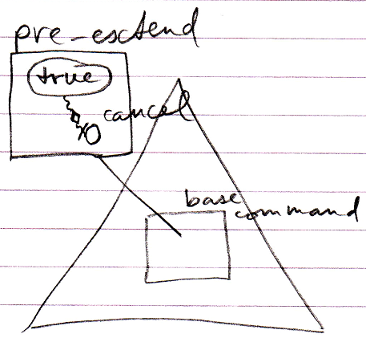

This cancels the execution of the base command.

Author & Copyright: Jan-Joost van Zon Date: May 19, 2010 – July 17, 2010 Location: Oosterhout, The Netherlands Status: Finished

